PEDIATRIC DEVICE INNOVATORS FORUM
PDIF 5 Media Kit

A great need currently exists for medical devices designed specifically for children.

Pediatric Device Innovators Forum (PDIF) is a recurring collaborative educational experience designed to connect and foster synergy among innovators across the technology development ecosystem who are interested in pediatric medical device development.

A collaboration between the FDA and the five Pediatric Device Consortia (PDC):
- Pennsylvania Pediatric Medical Device Consortium, Robert Levy, M.D.
- National Capital Consortium for Pediatric Device Innovation 2.0, Kolaleh Eskandanian, Ph.D., M.B.A.
- Southwest National Pediatric Device Innovation Consortium, Chester Koh, M.D.
- University of California San Francisco-Stanford Pediatric Device Consortium, Michael Harrison, M.D.
- The West Coast Consortium for Technology & Innovation in Pediatrics, Juan Espinoza, M.D.

Thank you for helping us reach more people by the details of our upcoming Pediatric Device Innovators Forum! Below are several templates you can use across any number of platforms. You can click on the links in the Table of Contents below to jump to the specific template you want.

Questions? Contact southwestpdc@bcm.edu

Graphic: Logo
Download the image at this link: https://tinyurl.com/pdiforum-ogo

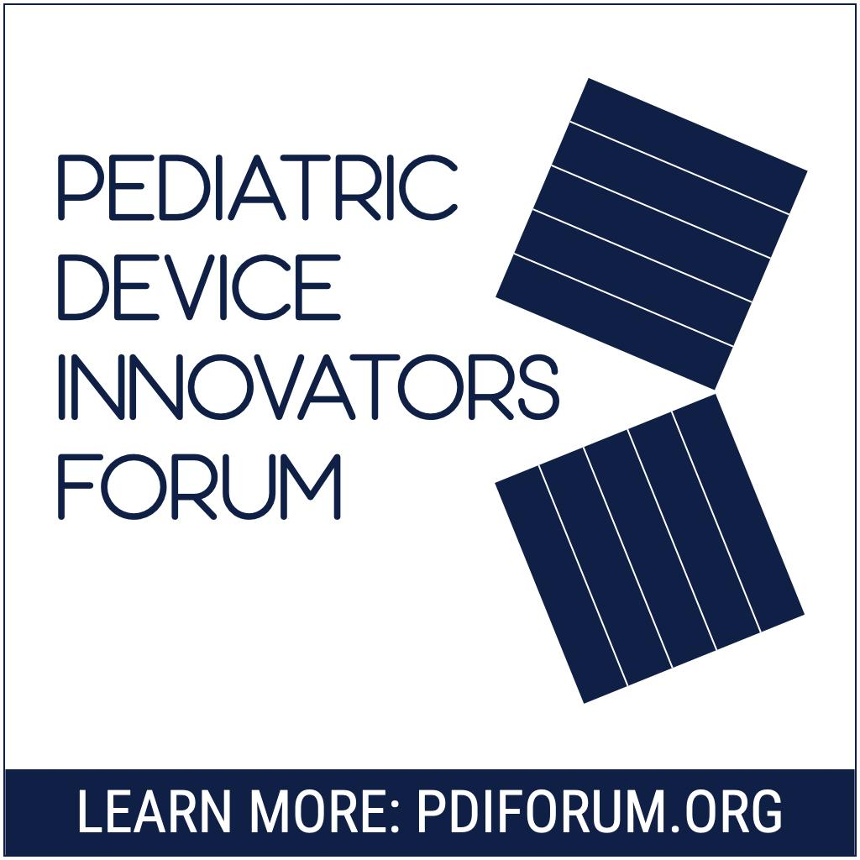

Download the image at this link: https://tinyurl.com/SWPDC-Logo

Graphic: Flyer
Download the image at this link: (not available – please copy / paste the figure below)

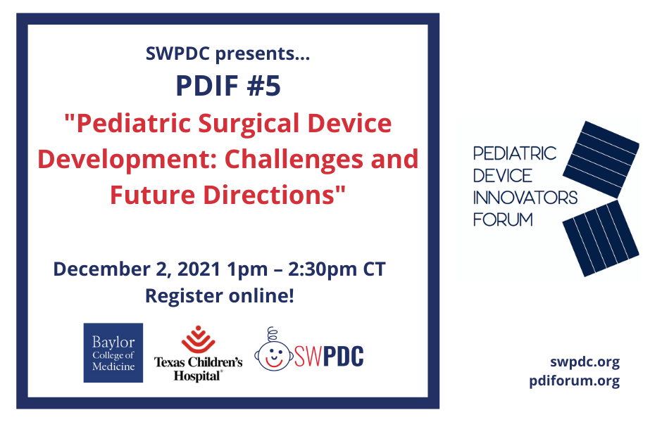

LinkedIn
On December 2 at 1 PM CT, join the FDA and the five Pediatric Device Consortia for a presentation on pediatric surgical device development from medical device experts followed by an interactive panel discussion among participants.
Registration is free and open to the public.
Learn more & register here: https://www.pdiforum.org
Do you develop pediatric devices? Join the SWPDC! https://swpdc.org
#webinar #medicaldevices #pediatricdevices #pediatricsurgery
@SWPDC

Twitter
Calling all pediatric clinicians and surgeons, academia, engineers, #medtech industry partners, entrepreneurs, investors & more! Register for the last virtual #Pediatric Device Innovators Forum of the year on Dec 2, 2021 at 1 PM CT: https://www.pdiforum.org/
@US_FDA
#MedicalDevice

Email: Announcement to Your Network

Register today for PDIF #5 hosted by the SWPDC!

Thursday, December 2nd, 2021 | 1:00pm – 2:30pm CT (2:00pm – 3:30pm ET)

“Pediatric Surgical Device Development: Challenges and Future Directions“

Learn more & register here: https://www.pdiforum.org/

Each year the SWPDC hosts a symposium inviting all clinicians, engineers, entrepreneurs, and investors. Starting in 2021, The Pediatric Device Innovators Forum (PDIF) was introduced as a collaboration between the FDA and the five Pediatric Device Consortia (PDC).
PDIF is a recurring collaborative educational experience designed to connect and foster synergy among innovators across the technology development ecosystem who are interested in pediatric medical device development.

